Press release from the Epiroc Tools & Attachments and Surface divisions

For further information please contact:
Anja Kaulbach, Global Communication & Brand Manager Tools & Attachments division
+49 (0)173-72-55-139, anja.kaulbach@epiroc.com

Bauma 2022: Reach new levels of construction with Epiroc

Welcome to Epiroc, Booth FS 1208/1 at Bauma 2022. Automation, digitalization, and data driven productivity development are transforming the entire construction industry, from tunneling and infrastructure to demolition and waste management. At Epiroc, we strive to help customers reach new levels by working smarter, maximizing our use of the latest technologies, and developing new ways of raising efficiency while improving sustainability.

New technologies are key in helping our customers to stay competitive. Our aim is to offer cutting edge equipment, software and services and ensure that our customers get maximum benefits from the ongoing digital evolution.

Below is information on the latest innovations from Epiroc. Visit our stand for more details.

New model added to successful V Cutter range
In April this year Epiroc launched its V-shaped drum cutter, setting a new standard in trenching and quarrying. The V Cutter is a brand-new way to work with rock, concrete wall and surface profiling, trenching, soft rock excavation, frozen soil excavation, and demolition. A patent pending solution, it has been rigorously tested in all these applications.

Mounting the drums in a V-shape enables a cut with a flat base and no material is left untouched between the drums. Where a regular drum cutter must move from side to side to create an even trench, an approach that causes extra wear on the carrier arm, the V Cutter can reach the same result by just going straight. This means the user can dig a more accurate trench much faster. It basically works like a bucket, which makes it easier to use, friendlier for the carrier and a lot less energy and time consuming. A seemingly simple solution with extraordinary effectiveness, the V Cutter enables energy savings of up to 40%.

In addition, compared to a chain cutter the user saves more than 40% on picks and up to 50% on maintenance time. The investment is up to 25% lower than for a chain cutter and the lower weight makes it possible to use a smaller carrier.

At Bauma, Epiroc will introduce the latest addition to the V Cutter range – a smaller model suitable for carriers of 15-28 tons.

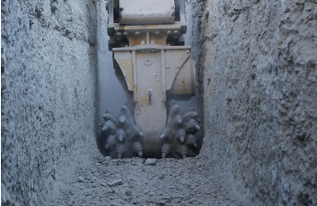

Photo link

Hydraulic breaker working tools on demand: Pick your own size
Epiroc has now added a “tool on demand” concept to its supply of top-quality working tools for hydraulic breakers. Sometimes standard working tools are not enough – special applications often require a longer or shorter working tool or a special material.

High temperature applications require working tools in heat resistant vanadium steel. Other applications require longer tools or special shapes. With Epiroc, you can now order exactly what you need, in the size of your choice, with a variety of tool tip geometries. “Tool on demand” offers high flexibility based on applications or customer preferences. All lengths and shapes are available, just pick your own size.

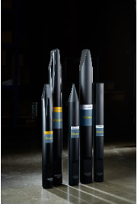

Photo link

Epiroc’s EU certified Bio Chisel Paste
The formulation of Epiroc´s Bio Chisel Paste is approved by the European commission for use in environmentally sensitive applications under certificate DE/027/243. As part of Epiroc’s aim to help protect the environment, all new Epiroc hydraulic breakers are delivered with Epiroc Bio Chisel Paste as standard.

Used to grease the wear bushings in the breakers, Epiroc Bio Chisel Paste is based on special synthetic esters that are easily biodegradable and tailor-made for hydraulic breakers. The paste helps prevent bushing wear and prolongs the life cycle of the tool. The paste has high load carrying characteristics with very good separation capacity and gives excellent performance across a wide range of temperatures, from –30°C up to +1,100°C.
Epiroc Bio Chisel Paste is suitable for automatic lubrication on Epiroc hydraulic breakers with ContiLubeTM II Micro or ContiLubeTM II, or for manual greasing with a grease gun on Epiroc or any other breakers.
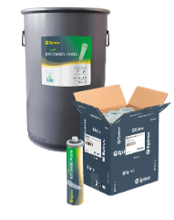

Photo link

SmartROC T35

This new SmartROC-model offer many smart features, providing a range of automated and sustainable solutions. The enhanced automation helps to achieve new levels of consistency and output. The model feature ingenious self-diagnostic capabilities, which helps to track down issues quickly and effectively. As a result, downtime is kept to a minimum. This new SmartROC will continue to lead the way within its segment.

Parts and Services
Visitors to the Epiroc booth at Bauma can find out more about our wide offering of parts, service and training relating to the products we have on-show at the exhibition, as well as other products and solutions in our ranges.

New, highly versatile down-the-hole hammer range
At Bauma, Epiroc will launch the latest range of 5” DTH hammers, a complete, new innovative platform. Each customer has unique circumstances in their operations; whether it’s the rock condition, type of rig used, length to be drilled, or even the altitude at which you are operating. We want to provide a tailormade solution for each of our customers.

The COP 57P platform is a wide range of hammers, fine-tuned to specific customer needs. This versatile new platform will replace the existing 5” hammer platform from Epiroc with which we have been market leaders for the past 20 years.

Hydraulic Rock Drill system HRD 100
If you thought the handheld drilling market consisted only of rock drills based on century old pneumatic technology that is very inefficient from an air consumption perspective, we have good news.

The HRD 100 system consists of the rock drill, power pack and a selection of pusher legs. Together they have two missions: The first is to provide hydraulic drilling that helps you exceed your production targets in a safe way. Thanks to the hydraulic system, you don’t have to worry about losing production time due to poor air pressure at large depths.

We have also gone out of our way to design a system that helps you avoid heavy lifting and wasting precious energy. The second mission is to provide good value for money, over a long period of time. To succeed, we use only the best parts and materials available and combine them with active security systems that protect both you and the equipment.

EssentialLine tophammer tools
At Epiroc we can offer our customers the most attractive cost per meter for rock drilling tools. The core features of our EssentialLine working tools are wear resistance and robustness, and the range includes moil points, flat chisels (cross) and blunt tools.

Epiroc products and solutions are designed to increase the overall productivity of our customers’ operations by increasing the rate of penetration of our drilling tools and their overall service life. However much or however little drilling our customers will do in their operations, our priority is to ensure that the cost per meter is as low as possible, with sustained hole quality and safety.

At Bauma, Epiroc will showcase a selection of the EssentialLine tophammer range consisting of bits and rods mainly used in surface applications.

Rock Drilling Tools
Epiroc has frequently been a pioneer in the world of hard materials for drilling. Now we are introducing Powerbit X rock drilling tools with diamond-protected buttons – the technology is called PCD (polycrystalline diamond).

Changing drill bits is a safety risk. The diamond layer of Powerbit X gives the drill bits a longer service life, which means fewer changes and less exposure to danger for operators. ‬‬The two-millimeter diamond layer can help improve workplace safety, reduce downtime and minimize CO₂ emissions. ‬‬‬‬‬‬

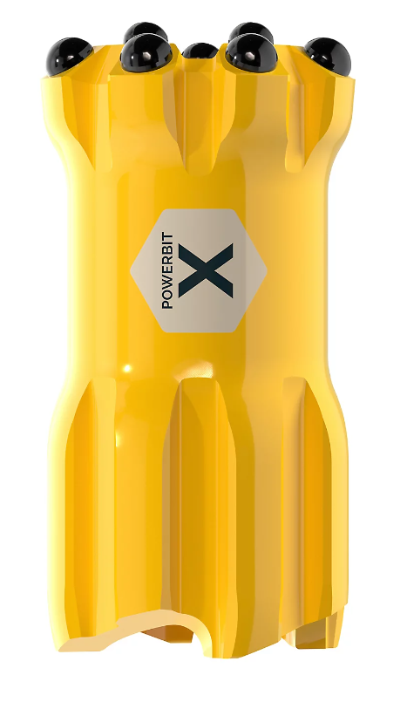

Photo link

Skid Pump system resin mixing and injection system
Rock bolting can sometimes be the bottleneck within the drill and blast cycle, leading to difficulties to predict work task scheduling. A recent development is the use of two-component pumpable resin for the anchoring of rockbolts and cable bolts.

The two-component system is delivered by a pump unit and is injected through a nozzle. The mixed resin begins to gel immediately, setting into a strong solid mass with excellent mechanical properties. When injected through hollow rockbolts the viscous mix fills the annular space between the bolt and the borehole in order to create a full column bond independent of the size of the hole.

For support using cable bolts or solid bars
The pumpable resin can be pumped into the borehole through an injection pipe prior to insertion of the cable or bolt. The setting time is adjusted to achieve a longer open time, enabling installation of a cable or solid bolt into a pre-filled borehole. Once mixed, the set resin is unaffected by water. The product is non-foaming and can even adhere to damp surfaces.

The pumpable resin is available in different reaction times and requires a 1:1 volumetric ratio between the resin and catalyst. Deviations from the ratio results in a reduction in cured resin strength.

Epiroc developed a resin mixing and injection system for the Boltec, ensuring a quality resin mix for every installation. The closed loop system controls the flow rate of each component separately ensuring the ratio is maintained and the volume of resin injected is monitored. The Skid Pump system is a replica of the Boltec resin injection system, allowing off-rig pumping and installation of pumpable resin rock reinforcement systems.

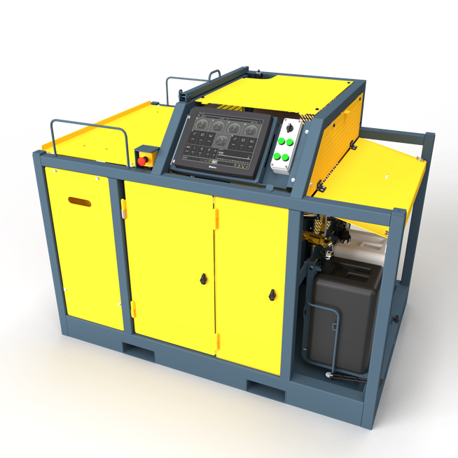
SARS with screen.

Introducing Mobilaris Tunneling Intelligence – a new suite of digital solutions
Based on the successful use of Mobilaris Mining Intelligence products in mines globally, these solutions have been fine-tuned to meet tunneling construction needs.

Knowing that all personnel are in a safe location is key in all conditions but especially during blasting, danger, or an evacuation. What you can measure, you can stabilize; what you can stabilize, you can improve. The new digital tunneling solutions make the tasks of planning and following up on progress much smoother. A digital workflow can help to drastically improve efficiency. Go from monitoring work orders to becoming operational, and report progress in real time at the face. An extra bonus with this way of working is that there is no need for manual reporting after the shift.

The Mobilaris Tunneling Intelligence suite includes the following software products:
• Mobilaris Situational Awareness
• Mobilaris Planning and Scheduling
• Mobilaris Operator Client
• Mobilaris Productivity Analytics

Mobilaris Situational Awareness: example of a 3D tunnel map.
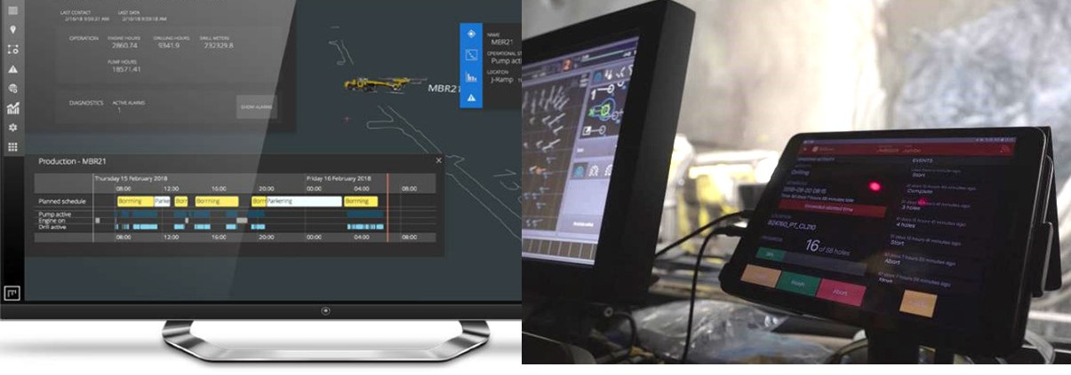
Left: Mobilaris Planning and Scheduling. Right: Mobilaris Operator Client.

My Epiroc boosts productivity and reduces downtime
My Epiroc is a digital platform for our customers where they can manage their daily business. The platform is role based and allows operators, fleet managers, buyers, technicians, managers, and other personnel to work more smoothly and efficiently.

With My Epiroc they not only have the tools needed to keep track of the fleet and its status, they also get insights to its service needs, and simple ways to track orders and follow up on any support requests as they arise. This increases confidence in making the right decisions based on information reported by machines and colleagues.

My Epiroc allows access to the information from any modern web enabled device at any location. My Epiroc is designed as “mobile first”, i.e., designed for mobile devices first and then for desktops.

my.epiroc.com

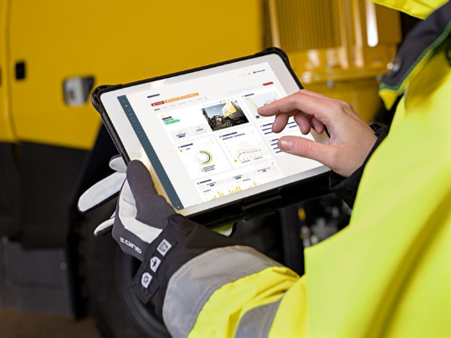

Increase fleet efficiency with My Epiroc – track everything, access from anywhere, act any time.

